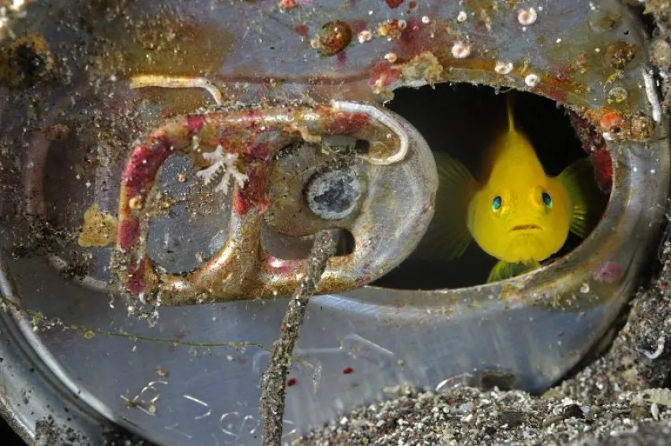
Finding NEMO
A remarkable event once occurred in his homeland — one that many people talked about.
Some shared it online, while others spoke about it in different places.
Your task is to investigate this event and uncover the full story behind it, especially in one article .
Flag format:
Securinets{species_name_child_message_eventsurvivor}

Solver:
Securinets{Gobiodon_okinawae_Air_raid_JohnG.Schmitt}
https://time.com/archive/6806733/okinawa-death-from-the-sky/
http://fr.wikipedia.org/wiki/Gobiodon_okinawae
https://en.wikipedia.org/wiki/1959_Okinawa_F-100_crash

